

WQX Plug-In Starter Kit
Installation and Administration Guide

EN-Node

Version: 1.5

9/14/2010



11 Princess Road, Unit A
Lawrenceville, New Jersey 08648
www.enfotech.com

Restriction on Use and Disclosure of Document Information

This document includes data that should not be disclosed outside the business entity for which it was intended, indicated as the recipient on this title page. The entire document is copyrighted by enfoTech and is protected under the US copyright law and international treaties. No part of this document may be reproduced or transmitted in any form or by any means, electronic or mechanical, for any purpose, without express written permission from enfoTech & Consulting Inc.

Copyright © 2001 – 2010 by enfoTech & Consulting Inc. All Rights Reserved.

Revision History
Version | Date | Created By | Reviewed By | Description
1.4 | 4/22/2010 | Doug Timms |  | Release for public use
1.5 | 9/14/2010 | Doug Timms |  | Updates for compatibility with latest Node version and support for users without DataFlow Wizard.

Tables of Contents

1 Document Purpose 4
2 Plug-In Overview 4
3 Installing the Plug-In 7
3.1 Prerequisites 7
3.2 Installation Package Contents 7
3.3 Pre-Installation Preparation 7
3.4 Installation Instructions 8
4 How to Use / Test the Plug-In 12
4.1 Pulling WQX Lookup Values from EPA 12
4.2 Upload WQX to the WQX data source and Submit WQX Data to EPA 15
4.3 Generate and Submit WQX Data to EPA 17
5 Appendix A: ReceiveEPAWQXLookups Reference 19
5.1 Plug-In Purpose 19
5.2 Plug-In Overview 19
5.3 Plug-In Configuration 19
6 Appendix B: UploadWQX Reference 20
6.1 Plug-In Purpose 20
6.2 Plug-In Overview 20
6.3 Plug-In Configuration 20
7 Appendix C: GenerateAndSubmitWQX Reference 21
7.1 Plug-In Purpose 21
7.2 Plug-In Overview 21
7.3 Plug-In Configuration 21
8 Appendix D: GetWQXErrorReport Reference 22
8.1 Plug-In Purpose 22
8.2 Plug-In Overview 22
8.3 Plug-In Configuration 22

Document Purpose
This purpose of this document is to provide guidance on the setup, use, and maintenance of the EN-Node WQX Plug-ins.

Plug-In Overview
Four different WQX plug-ins are available under the WQX data flow:
- Import WQX Data
- Import EPA WQX Lookup Values
- Submit WQX
- Download Submission Error Report

No one will use all four plug-ins: instead, depending on how you wish to manage your WQX data, you will select one or more of the four plug-ins and implement only those you need.

The following diagram outlines the four available WQX plug-ins:

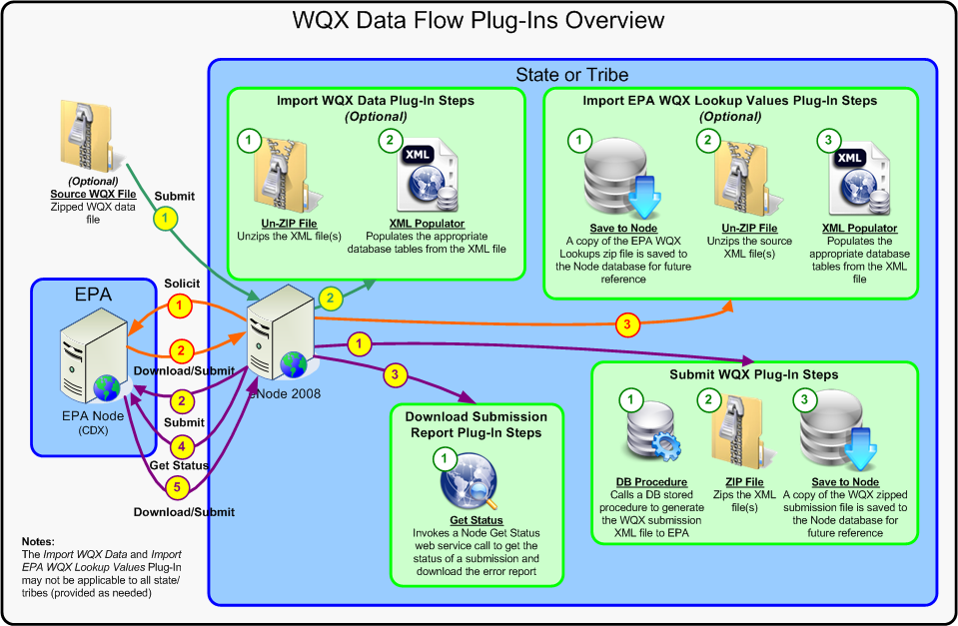
Figure 1: WQX Data Flow Plug-Ins Overview

- Plug-in #1 - Import WQX Data:
  - Purpose: The Import WQX Data plug-in is used when you receive WQX XML files from a 3rd party and wish to import those files into your own Node and possibly parse the data into your own local Water Quality data management system. This plug-in is used in cases where a 3rd party (such as a local volunteer monitoring agency) is generating XML files, and you will be submitting to EPA on their behalf. It is also useful in situations where you are generating WQX XML files outside of your Node (perhaps using EPA’s WQX-Web application) and wish to save a copy of the data in your own local data management system.
  - What Does it Include: Under the Import WQX Data plug-in, the following procedure occurs:
User manually submits a zipped WQX source file to the EN-Node system, supplying the appropriate EN-Node Operation name that will parse the data file(s) into the appropriate tables/columns in the database
The EN-Node invokes the Import WQX Data plug-in. By default, this Plug-In includes the following steps:
- Unzip File: Decompresses the zipped WQX file such that the WQX XML files can be read
- XML Populator: Populates the data contained within the XML data files, using a predefined mapper and template, to the appropriate tables and columns in the source WQX database

- Plug-in #2 - Import EPA WQX Lookup Values:
  - Purpose: The Import EPA WQX Lookup Values plug-in is used when you wish to retrieve the latest lookup values from EPA’s WQX system. This is most useful for customers that have their own local Water Quality Data Management System and wish to periodically retrieve WQX lookup values (e.g. Characteristic Names list, Unit Code lists, etc) in order to synchronize their system with EPA-WQX.
  - What Does it Include: Under the Import EPA WQX Lookup Values plug-in, the following procedure occurs:
EN-Node calls a Solicit against the EPA CDX and supplies the following information:
- Security Token: Security token issued by NAAS from the Authenticate response
- Request Name: WQX.GetDomainValueByElementName_v2.0
The EPA CDX calls a Submit to EN-Node to submit the appropriate zipped WQX Lookup file to the State/Tribe
The EN-Node invokes the Import EPA WQX Lookup Values plug-in. By default, this Plug-In includes the following steps:
- Save To Node: The solicited and submitted WQX file is stored in the Node database for future reference. This file is stored along with the transaction ID and submission date. This allows Node and WQX domain administrators at the State/Tribe to review any files that have been submitted by EPA for troubleshooting and/or recordkeeping purposes
- Unzip File: Decompresses the zipped WQX file such that the WQX XML files can be read
- XML Populator: Populates the data contained within the XML data files, using a predefined mapper and template, to the appropriate tables and columns in the source WQX database

- Plug-in #3 – Submit WQX:
  - Purpose: The Submit WQX plug-in is used when you generate WQX data from your local Water Quality Data Management system and wish to submit to EPA. This is the most common WQX dataflow.
  - What Does it Include: Under the Submit WQX plug-in, the following procedure occurs:
The EN-Node invokes the Submit WQX plug-in when triggered by the Administrator. By default, this Plug-In includes the following steps:
- DB Procedure: Database procedure to extract data from the WQX source database, map the data against an approved WQX schema, and present the data in an XML submission file format
- Zip File: Compresses the WQX XML file into a ZIP file
- Save To Node: The compiled and zipped WQX file is stored in the Node database for future reference. This allows Node and WQX domain administrators at the State to review any files that have been generated and submitted to the EPA for troubleshooting and/or recordkeeping purposes
In EN-Node, the Administrator selects and submits the generated and zipped WQX file, from 1, to the EPA CDX

- Plug-in #4 – Download Submission Error Report:
  - Purpose: The Download Submission Error Report plug-in can be used in conjunction with Plug-in #3 above to retrieve an error report from EPA regarding the WQX submission. This plug-in is generally executed after a submission has been made to the EPA.
  - What Does it Include: Under the Download Submission Error Report plug-in, the following procedure occurs:
The EN-Node invokes the Download Submission Error Report plug-in. By default, this Plug-In includes the following steps:
- GetStatus: Component that calls a “Get Status” to the EPA CDX for the status of WQX submissions and once the submission files has been processed by the EPA, downloads and saves the error report to EN-Node

Installing the Plug-In

This section is intended for Node Administrators for the one time initial Plug-In installation and configuration. For Staff who wishes to use the WQX Plug-Ins, please skip to section Error: Reference source not found.

Prerequisites
- EN-Node has been installed
- A local Water Quality data source exists in SQL Server or Oracle format

Installation Package Contents
This section identifies the files that are provided as part of the WQX Plug-In Installation Package. The WQX Plug-In Installation Package includes the following:

File(s) for Retrieving WQX Lookup Values from EPA (Optional):
- WQX_Lookups_ToDB_Populator.xml: Provides the logic to map the EPA WQX Lookup values from an XML file to the source database
- WQX_Submit_ReceiveEPAWQXLookups_Wizard.xml: Node Plug-In Configuration file that defines the step-by-step logic for the import of WQX Lookup Values from EPA

File(s) for Importing WQX XML files to the Node from external system (Optional):
- WQX_ImportWQX_ToDB_Populator.xml: Provides the logic to parse an uploaded WQX XML file in WQX v2 format into your local water quality database.
- WQX_Submit_UploadWQX_Wizard.xml: Node Plug-In Configuration file that defines the step-by-step logic for the uploading of WQX XML files to the node from an external source.

File(s) for Generating WQX XML files from local database:
- DDL_NODE_WQX_XML_InsertUpdate.sql: Stored procedure script which generates an XML file for submission to the EPA CDX
- WQX_Solicit_GenerateWQX_Wizard.xml: Node Plug-In Configuration file that defines the step-by-step logic for the generation of XML in WQX format.
- WQX_Stylesheet.xslt: XML stylesheet that displays WQX XML files in more human-readable format. Used for reviewing generated files prior to submission to EPA.

File(s) for retrieving status of WQX submission and downloading Submission Error Report:
- None

Pre-Installation Preparation
This section identifies steps that should be performed prior to installation.
If you plan on supporting the import of WQX lookup values from EPA (if applicable):
- Update WQX_Lookups_ToDB_Populator.xml with the correct logic to import data from the source XML file to your WQX data source. Because most states/tribes have their own unique databases, this file will need to be updated to correctly import the data values into the right columns. In most cases, the only portions of this file that need to be updated are the SQL statements and connection string.
- Update WQX_Submit_ReceiveEPAWQXLookups_Wizard.xml with your state or tribe specific information:
  - Correct the connection string to point to your WQX data source:
i.e. <parameter name="dataSource" value="MSSQL:server=enfo_001; database=WQX;UID=nodeadmin; password=nodeadmin;" type="System.String" />

If you plan on Importing WQX XML files to the Node from external system (if applicable):
- Update WQX_ImportWQX_ToDB_Populator.xml: with the correct logic to import data from the source XML files to your WQX data source. Because most states/tribes have their own unique databases, this file will need to be updated to correctly import the data values into the right columns. In most cases, the only portions of this file that need to be updated are the SQL statements and connection string.
- Update WQX_Submit_UploadWQX_Wizard.xml with your state or tribe specific information:
  - Correct the connection string to point to your WQX data source:
i.e. <parameter name="dataSource" value="MSSQL:server=enfo_001; database=WQX;UID=nodeadmin; password=nodeadmin;" type="System.String" />

If you plan on generating WQX XML files from local database:
- Verify the Node application server has permissions to access the Water Quality database
- Execute the DDL_NODE_WQX_XML_InsertUpdate.sql stored procedure on your WQX data source
- Update WQX_Solicit_GenerateWQX_Wizard.xml with your state or tribe specific information:
  - Correct the connection string to point to your WQX data source:
i.e. <parameter name="dataSource" value="MSSQL:server=enfo_001; database=WQX;UID=nodeadmin; password=nodeadmin;" type="System.String" />

If you plan on downloading the WQX submission report to the Node database:
- Update WQX_GetStatusDownload_GetWQXErrorReport_Wizard.xml with your state or tribe specific information:
  - Correct the NAAS user authentication to use your approved NAAS user account:
i.e. <parameter name="authUser" value="node_support@enfotech.com" type="System.String" />
  - Correct the NAAS password authentication to use your approved NAAS user account:
i.e. <parameter name="authPassword" value="NAASPassword" type="System.String" />

Installation Instructions
To create and configure the WQX Node Plug-Ins please follow these steps:

- Log into the Node Administration application as Node Admin
- Create a WQX Domain:
  - Click “New Domain” button that is located in the Node Domains webpart
  - Under the New Node Domain Information form:
    - Enter in Domain Name = WQX
    - Select Status = Running
    - Check Allowed Web Services = Submit; Download; Solicit
    - Under the Domain Administrators section, check off which Node Admin Console users should be domain administrators
    - Click “Save” button to confirm and create the domain

- (Optional) Create ReceiveEPAWQXLookups Submit Plug-In (for importing WQX Lookups):
  - Return to the Node Dashboard screen
  - Under the Node Domains webpart, click the “Go to Operations” link for the WQX Domain
  - Click “Create Operation by XML” button
  - When prompted, locate and upload the WQX_Submit_ReceiveEPALookups_Wizard.xml file
  - Click the “Save” button
  - You will also need to load the WQX_Lookups_ToDB_Populator.xml populator file directly into the database.

- (Optional) Create WQX Submit Operation (for importing externally generated WQX Data):
  - Return to the Node Dashboard screen
  - Under the Node Domains webpart, click the “Go to Operations” link for the WQX Domain
  - Click “Create Operation by XML” button
  - When prompted, locate and upload the WQX_Submit_UploadWQX_Wizard.xml file
  - Click the “Save” button
  - You will also need to load the WQX_ImportWQX_ToDB_Populator.xml populator file directly into the database.

- Create WQX Solicit Operation (for generating WQX data from local database):
  - Return to the Node Dashboard screen
  - Under the Node Domains webpart, click the “Go to Operations” link for the WQX Domain
  - Click “Create Operation by XML” button
  - When prompted, locate and upload the WQX WQX_Solicit_GenerateWQX_Wizard.xml file
  - Click the “Save” button

- Create WQX Error Report Download (for retrieving the status of WQX submission and downloading the associated error report(s) from the EPA to the Node database):
  - Return to the Node Dashboard screen
  - Under the Node Domains webpart, click the “Go to Operations” link for the Node Domain
  - If an operation called GetStatusTask does not exist, click the “Create New Operation” button. If the
  - Under the New Operation Information screen:
    - Enter in Operation Name = GetStatusTask
    - Select Status = Running
    - Select Operation Type = Scheduled Task
    - Click “Next” button
  - Under the Task Schedule section:
    - DLL Path = path to the Node.ENFO.dll on your server. Should be something like: D:\eNode2008\PlugIn\Node.ENFO\Node.ENFO.dll
    - ClassName = Node.ENFO.GetStatusTask
    - Add 2 parameters:
      - LOG → value = false
      - MTOM -> value = false
    - Select Task Schedule Type = Daily
    - Select Start Date = Current Date
    - Select End Date = 12/31/2050
    - Enter in Interval = 5
    - Select the radio for Minutes
    - Click “Save” button

- Create WQX Generate-Submit Operation Manager:
  - Return to the Node Dashboard screen
  - Under the Node Configuration webpart, click the icon link for (7) Operation Manager
  - Under the Operation Manager screen click the “Add Operation” button
  - Under the Configure Operation screen:
    - Select Operation Name = GenerateAndSubmitWQX
    - Check Enable Generate, Enable Submit, and Enable GetStatus options
    - Under the Submit section:
      - Enter in URL =
    - Test Node 1.1: http://test.epacdxnode.net/cdx/services/NetworkNodePortType_V10
    - Test Node 2.0: http://test.epacdxnode.net/cdx-enws20/services/NetworkNode2?wsdl
    - Production Node 1.1: https://cdxnode.epa.gov/cdx/services/NetworkNodePortType_V10
    - Production Node 2.0: https://cdxnode.epa.gov/cdx-enws20/services/NetworkNode2?wsdl
      - Enter in User Name = Enter NAAS assigned User ID
      - Enter in Password = Enter NAAS assigned Password
      - Enter in Domain Name = default
      - Enter in Data Flow Name = WQX
    - Under GetStatus section:
      - Completed Status = Completed
      - Failed Status = Failed
    - Click “Save Operation” button

- (Optional) Create WQX Upload-Submit Operation Manager (for importing and submitting WQX Data):
  - Return to the Node Dashboard screen
  - Under the Node Configuration webpart, click the Task icon link for (7) Operation Manager
  - Under the Operation Manager screen:
    - Click “Add Operation” button
  - Under the Configure Operation screen:
    - Select Operation Name = UploadWQX
    - Check Enable Upload and Enable Submit checkbox
    - Under the Submit section:
      - Enter in URL =
    - Test Node 1.1: http://test.epacdxnode.net/cdx/services/NetworkNodePortType_V10
    - Test Node 2.0: http://test.epacdxnode.net/cdx-enws20/services/NetworkNode2?wsdl
    - Production Node 1.1: https://cdxnode.epa.gov/cdx/services/NetworkNodePortType_V10
    - Production Node 2.0: https://cdxnode.epa.gov/cdx-enws20/services/NetworkNode2?wsdl
      - Enter in User Name = Enter NAAS assigned User ID
      - Enter in Password = Enter NAAS assigned Password
      - Enter in Data Flow Name = WQX
    - Click “Save Operation” button

- Grant WQX Operation Privileges to Default NAAS User:
  - Return to the Node Dashboard screen
  - Under the Favorite Links webpart, click on the “Node User” link name
  - Under the Node User search screen, search for the Default NAAS user
  - Click the “View” icon for the appropriate NAAS User
  - Under the NAAS Node User Operation Privileges section, check off all the Operations that were created for the WQX domain
  - Click “Save” button to confirm and save changes

- Setup Plug-In Administrators:
For any person that wishes to access the WQX portions of the Node Administration Utility (to review WQX submissions, etc), you will need to grant them rights to be a WQX Data Flow Administrator. To set this up, follow these steps in Node Administration:
  - Create a new Node Admin Console User (if one does not already exist)
  - Return to the Node Dashboard screen
  - Under the Node Domains webpart, click on the “WQX” link name
  - Under the Node Domain Information window:
    - Under the Domain Administrators section, check off the Node Admin Console User that wish to be the WQX Administrators
    - Click “Save” button to confirm and save changes

How to Use / Test the Plug-In

Pulling WQX Lookup Values from EPA
EPA provides a web service with the latest WQX lookup values (such as Unit Codes, Analytical Method Codes, Characteristic Names, etc). Some customers may prefer to pull this data from EPA and import the lookup values into their State or Tribal water quality system.

Step 1: Authenticate to EPA CDX
First authenticate to EPA CDX Node using the Node Client tool. Click on the Authenticate link on the menu to authenticate your account:
- Node Address: Select or provide the EPA CDX URL endpoint, which can be either:
  - Test Node 1.1: http://test.epacdxnode.net/cdx/services/NetworkNodePortType_V10
  - Test Node 2.0: http://test.epacdxnode.net/cdx-enws20/services/NetworkNode2?wsdl
  - Production Node 1.1: https://cdxnode.epa.gov/cdx/services/NetworkNodePortType_V10
  - Production Node 2.0: https://cdxnode.epa.gov/cdx-enws20/services/NetworkNode2?wsdl
- User Name: Enter your NAAS username
- Password: Enter your NAAS password
- Then click the Authenticate button

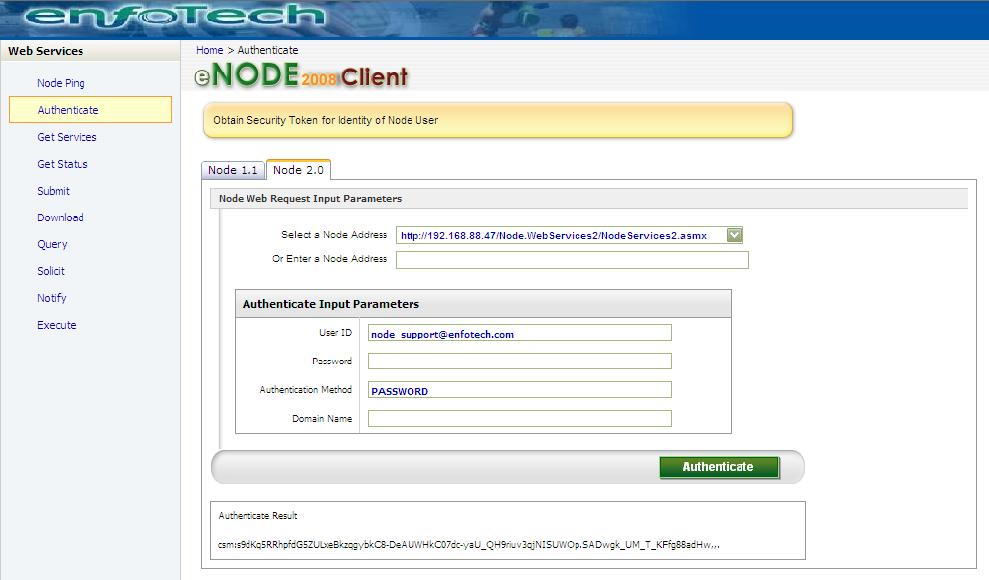

The Authentication Result should show a security token similar to the one above.

Step 2: Call EPA Solicit Service to Request WQX Lookup Values
Click on the Solicit link on the menu to Solicit data from EPA. Fill in the following information:
- Node Address: Select or provide the EPA CDX URL endpoint, which can be either:
  - Test Node 1.1: http://test.epacdxnode.net/cdx/services/NetworkNodePortType_V10
  - Test Node 2.0: http://test.epacdxnode.net/cdx-enws20/services/NetworkNode2?wsdl
  - Production Node 1.1: https://cdxnode.epa.gov/cdx/services/NetworkNodePortType_V10
  - Production Node 2.0: https://cdxnode.epa.gov/cdx-enws20/services/NetworkNode2?wsdl
- Security Token: copied from step above (if not pre-populated)
- Request Name: WQX.GetDomainValueByElementName_v2.0
- Then click the Solicit button

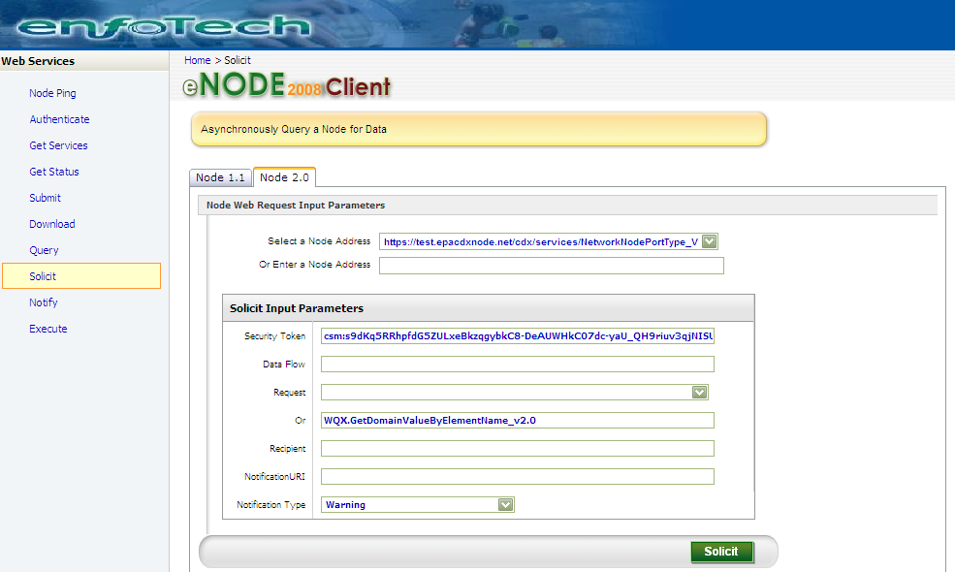

The Solicit Result should show a transaction ID at the bottom of the page.

Step 3 (Optional): Call Get Status to determine if File is ready yet:
Click on the Get Status link on the menu to get the status of the Solicit from the EPA. Fill in the following information:
- Node Address: Select or provide the EPA CDX URL endpoint, which can be either:
  - Test Node 1.1: http://test.epacdxnode.net/cdx/services/NetworkNodePortType_V10
  - Test Node 2.0: http://test.epacdxnode.net/cdx-enws20/services/NetworkNode2?wsdl
  - Production Node 1.1: https://cdxnode.epa.gov/cdx/services/NetworkNodePortType_V10
  - Production Node 2.0: https://cdxnode.epa.gov/cdx-enws20/services/NetworkNode2?wsdl
- Security Token: copied from step 1 above (if not pre-populated)
- Transaction ID: copied from step 2 above
- Then click the GetStatus button
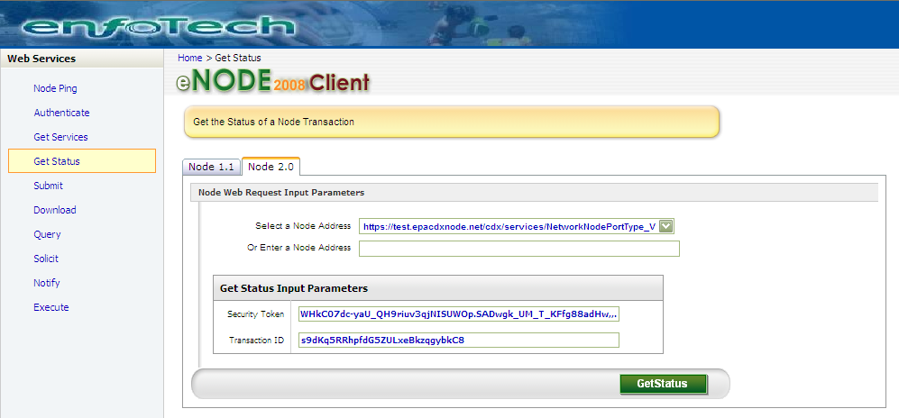

Step 4: Call Download to Download ZIP File Containing WQX Lookup Values
Click on the Download link on the menu to download the WQX Lookup values. Fill in the following information:
- Node Address: Select or provide the EPA CDX URL endpoint, which can be either:
  - Test Node 1.1: http://test.epacdxnode.net/cdx/services/NetworkNodePortType_V10
  - Test Node 2.0: http://test.epacdxnode.net/cdx-enws20/services/NetworkNode2?wsdl
  - Production Node 1.1: https://cdxnode.epa.gov/cdx/services/NetworkNodePortType_V10
  - Production Node 2.0: https://cdxnode.epa.gov/cdx-enws20/services/NetworkNode2?wsdl
- Security Token: copied from step 1 above (if not pre-populated)
- Transaction ID: copied from step 2 above
- Then click the Download button

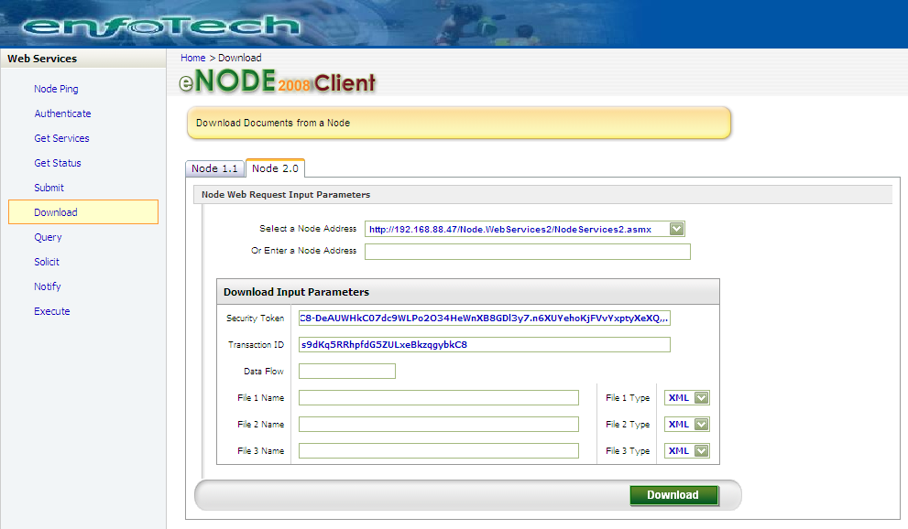

You should be returned with a ZIP file called Results.zip. Click on the file link to download the Results.zip to your local computer.

Step 5: Call EN-Node Service to Load into Your Database
Use the same Node Client application to submit the Results.zip to your Data Flow. Click on the Submit link in the menu to import the Lookup values into the WQX data source. Fill in the following information:
- Node Address: Select or provide your local Node Web Service endpoint
- Security Token: copied from step 1 above (if not pre-populated)
- Data Flow: ReceiveEPAWQXLookups
- File 1: Locate and upload the Results.zip you just downloaded in the previous step
- File Type: ZIP
- Then click the Submit button

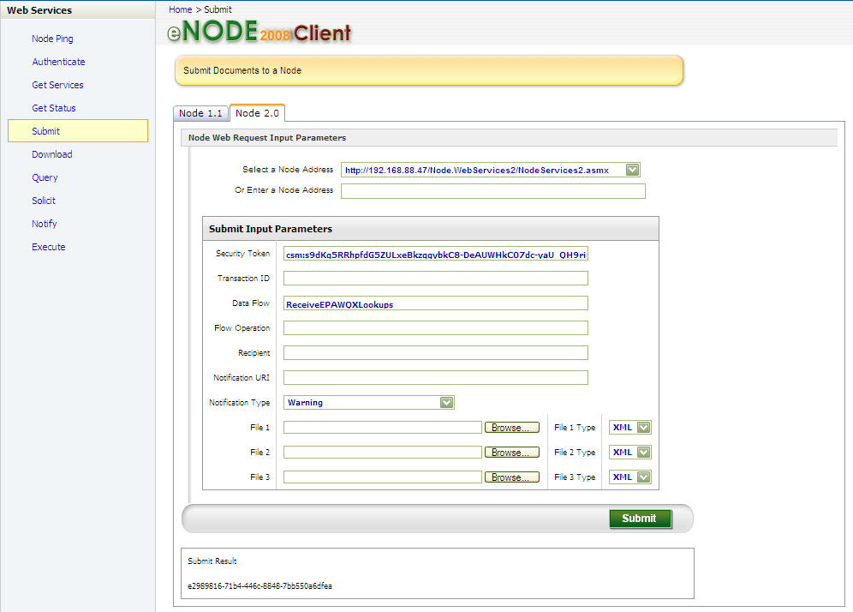

The system should return a security token at the bottom of the screen. The system has now loaded the WQX lookup values into your database. For more details, please refer to the ReceiveEPAWQXLookups reference located in the Appendix.

Upload WQX to the WQX data source and Submit WQX Data to EPA

After the Operation Manager has been installed and configured on Node Administration, follow the steps below to upload a WQX file generated externally (such as using EPA’s WQXWeb application). When this service is run, the zipped WQX file will be uploaded to the Node, parsed the zipped WQX source data’s XML file into the state/tribe WQX data source, and as well as submission of the WQX data to the EPA

Step 1: Obtain WQX Data in XML
First obtain a copy of the WQX data in XML format to import. Typically this is from EPA’s WQXWeb tool. File retrieved should be in ZIP format.

Step 2: Access Operation Manager
First log into Node Administration and under the Favorite Links webpart, click the Operation Manager link, as shown here:

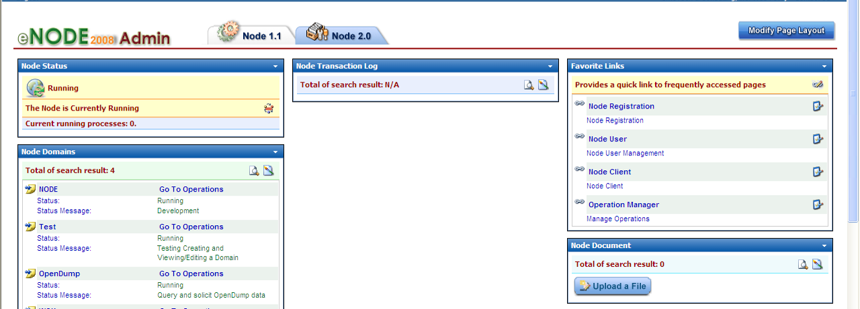

Step 3: Upload WQX Data to the Node
From the Selected Operation dropdown, select UploadWQX operation, as shown here:

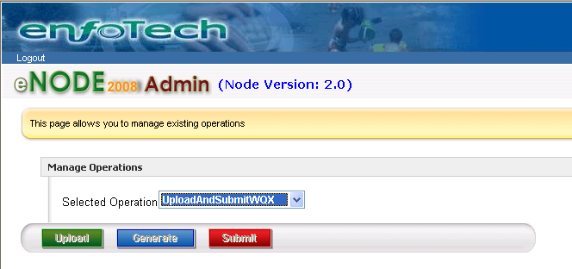

Then click on the Upload button to import the WQX data into the WQX data source. Select and upload the zipped XML file. Clicking the Upload button will save the WQX XML file to the Node database and also parse the XML contents to a local WQX database.

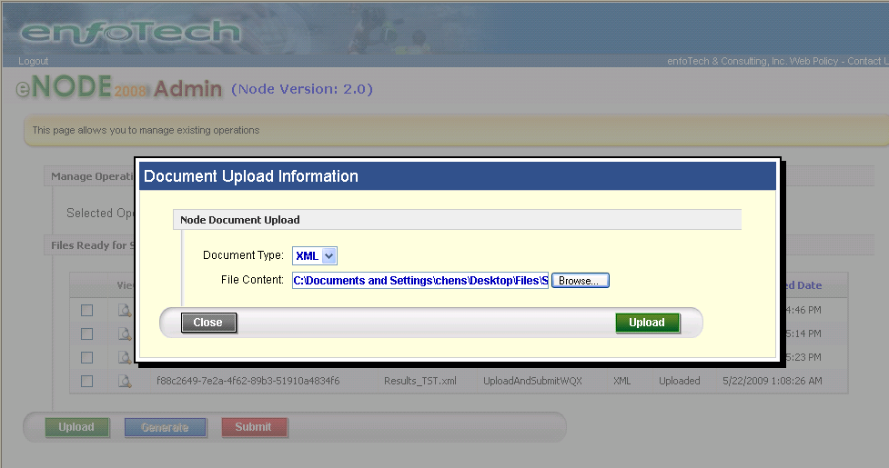

Step 4: Call Operation to Submit WQX Data to EPA
From the grid, check the checkbox for the uploaded WQX Data file and click the Submit button to submit the WQX file to the EPA CDX Node.

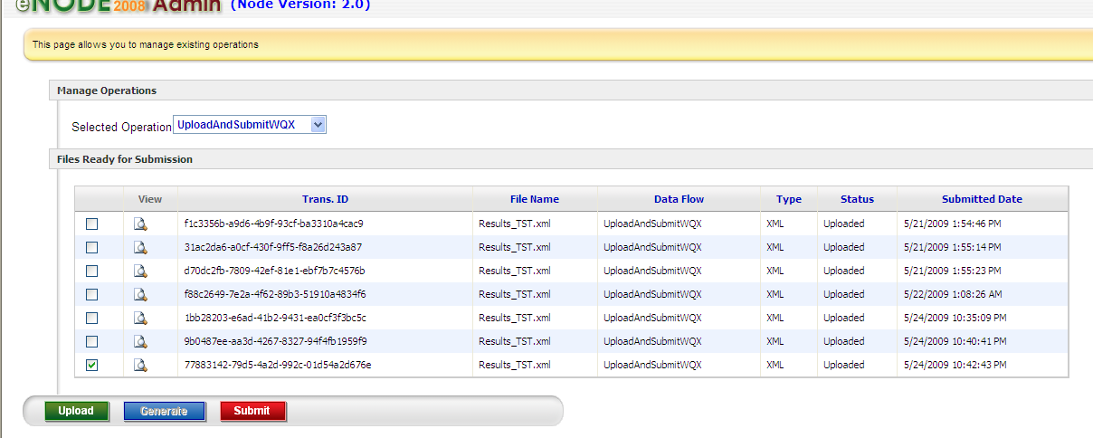

Generate and Submit WQX Data to EPA
If you have a local Water Quality database (in SQL Server or Oracle format) from which you will generate WQX XML files, please follow the steps below to generate the WQX submission file from the WQX data source and submit to EPA:

Step 1: Access Operation Manager
First log into Node Administration and under the Favorite Links webpart, click the Operation Manager link.

Step 2: Call Operation to Generate WQX Submission File
From the Selected Operation dropdown, select GenerateAndSubmitWQX operation. Click on the Generate button to generate the WQX XML submission file from the WQX data source.
Note: Generation of the WQX XML submission file may take some time, so the file may not be available

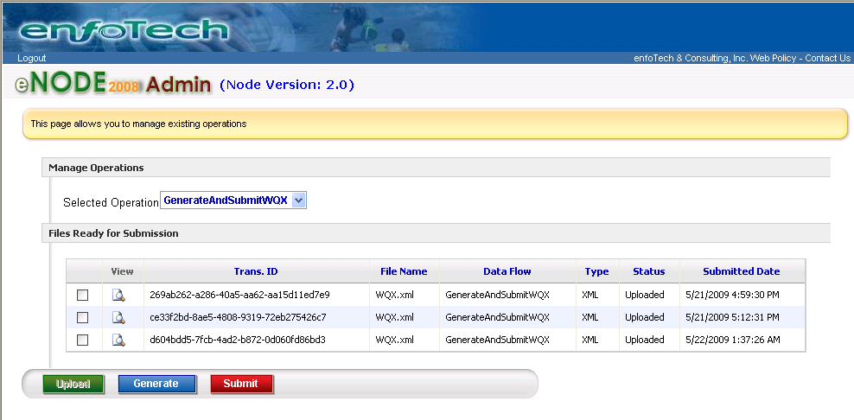

Step 3: Call Operation to Submit WQX Data to EPA
From the grid, check the checkbox for the generated WQX Data file and click the Submit button to submit the WQX file to the EPA CDX Node.

Appendix A: ReceiveEPAWQXLookups Reference

Plug-In Purpose
The ReceiveEPAWQXLookups Operation is a Submit service registered under the WQX domain. This appendix provides details on this plug-in and instructions on how you can modify the plug-in.

Plug-In Overview
The ReceiveEPAWQXLookups operation consists of 3 steps:

Step 1: Save to Node DB: This step saves a copy of the ZIP file you uploaded to the Node database. As with all files saved to the Node database, it is saved in the NODE_FILE_CABIN table.
- Input: Global::documents
- Output: SaveToNodeDB::Output

Step 2: Unzip WQX Lookup File: This step unzips the Zip file that was submitted. This step occurs in threaded mode, meaning that the operation does not wait for this step to complete before considering the operation complete.
- Input: Global::documents
- Output: Unzip::Output

Step 3: Populate WQX Lookup Values to Node Database: This step parses the XML file obtained from EPA and populates the values into your database. It does this by using the enfoTech XML Mapper Engine. The XML Mapper Engine uses a “Mapper” configuration file that contains the logic for parsing an XML file into a database. The mapper file for this Plug-In is called “PopulateWQXLookups_vX.xml”. This step also runs in threaded mode.
- Input: Unzip::Output
- Output: PopulateWQXLookups::output

Plug-In Configuration
The primary configuration that will be needed for this Plug-In is the modification of the XML parsing logic in the PopulateWQXLookups_vx.xml to match the structure of your water quality database. All State/Tribe specific information (account information and data source connection string) will also need to be modified, appropriately.

Appendix B: UploadWQX Reference

Plug-In Purpose
The UploadWQX Operation is a Submit service registered under the WQX domain. This appendix provides details on this plug-in and instructions on how you can modify the plug-in.

Plug-In Overview
The UploadWQX operation consists of 3 steps:

Step 1: Unzip WQX Lookup File: This step unzips the Zip file that was submitted. This step occurs in threaded mode, meaning that the operation does not wait for this step to complete before considering the operation complete.
- Input: Global::documents
- Output: Unzip::Output

Step 2: Save to Node DB: This step saves a copy of the unzipped XML file you imported to the Node database. As with all files saved to the Node database, it is saved in the NODE_FILE_CABIN table.
- Input: Unzip::Output
- Output: SaveToNodeDB::Output

Step 3: Populate WQX Values to Node Database: This step parses the XML file provided by the state/tribe and populates the values into your database. It does this by using the enfoTech XML Mapper Engine. The XML Mapper Engine uses a “Mapper” configuration file that contains the logic for parsing an XML file into a database. The mapper file for this Plug-In is called “WQXSubmission_ToDB_Populator.xml”. This step also runs in threaded mode.
- Input: Unzip::Output
- Output: WQXSubmission_ToDB_Populator::output

Plug-In Configuration
The primary configuration that will be needed for this Plug-In is the modification of the XML parsing logic in the WQXSubmission_ToDB_Populator.xml to match the structure of your water quality database. All State/Tribe specific information (account information and data source connection string) will also need to be modified, appropriately.

Appendix C: GenerateAndSubmitWQX Reference

Plug-In Purpose
The GenerateAndSubmitWQX Operation is a Solicit service registered under the WQX domain. This appendix provides details on this plug-in and instructions on how you can modify the plug-in.

Plug-In Overview
The GenerateAndSubmitWQX operation consists of 2 steps:

Step 1: DB Stored Procedure: This step calls a database stored procedure to generate the WQX submission XML file from the state/tribe WQX data source.
- SP Name: WQX_XML_InsertUpdate
- Output: DBProcedure::Output

Step 2: Zip WQX Lookup File: This step unzips the Zip file that was submitted. This step occurs in threaded mode, meaning that the operation does not wait for this step to complete before considering the operation complete.
- Input: DBProcedure::Output
- Output: Unzip::Output

Step 3: Save to Node DB: This step saves a copy of the unzipped XML file you imported to the Node database. As with all files saved to the Node database, it is saved in the NODE_FILE_CABIN table.
- Input: Unzip::Output
- Output: SaveToNodeDB::Output

Plug-In Configuration
All State/Tribe specific information (account information and data source connection string) will also need to be modified, appropriately.

Appendix D: GetWQXErrorReport Reference

Plug-In Purpose
The GetWQXErrorReport Operation is a scheduled task registered under the WQX domain. This appendix provides details on this plug-in and instructions on how you can modify the plug-in.

Plug-In Overview
The GetWQXErrorReport operation consists of 2 steps:

Step 1: GetStatus: This step retrieves the status of a submitted WQX XML file and if the file has been processed, downloads the error report associated with the report from the EPA to the local Node.
- Input: Operation Name
- Output: Error Report

Plug-In Configuration
All State/Tribe specific information (account information and data source connection string) will also need to be modified, appropriately.

